Data Preparation

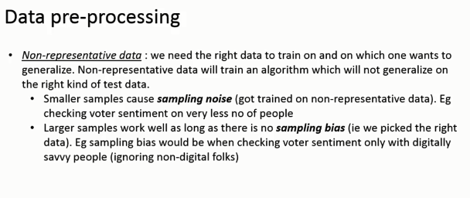

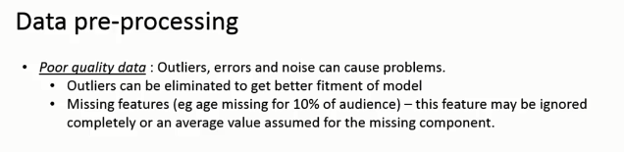

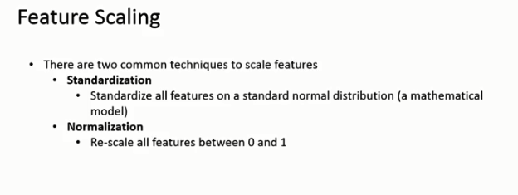

Standardization – StandardScalar

Normalization – MinMaxScalar

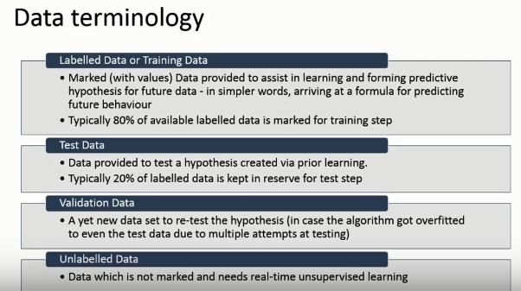

Common errors related to data

1. Missing values
2. Corrupted values
3. Timezone diferences
4. Date range errors, such as data registered from before sales started